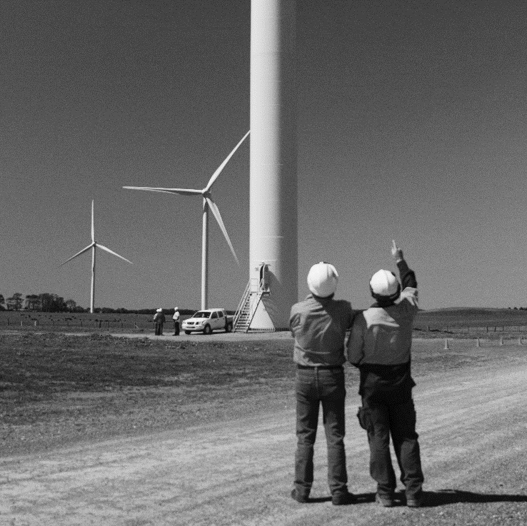
Product listing consultation form
FORM
CER-RET-042
v1.0 07/11/2022
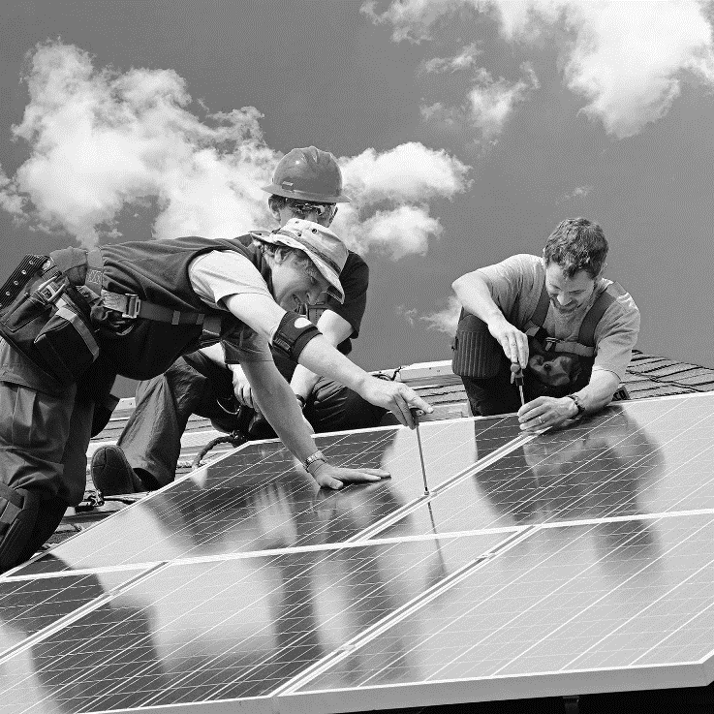

Introduction
Phase 2 changes are underway for the Small-scale Renewable Energy Scheme (SRES). Under the Renewable Energy (Electricity) Regulations 2001 (REE Regulations), the Clean Energy Regulator (CER) must publicly consult on whether it should nominate any person or organisation to publish the product listing for solar panels and inverters under the SRES.
This consultation is being undertaken to ensure that the best possible body and processes for component listing are thoroughly explored before any decision on nomination is made.
The CER is undertaking public consultation to gain feedback on whether it should nominate any person or organisation to publish the lists of approved products. It is also asking those submitting responses to provide reasons for their response. Please note, the CER is not seeking nominations of specific people or bodies at this time – only whether the CER should use its nomination power.
The feedback you give the CER will help it decide whether the CER should proceed to the stage of requesting bodies to make formal applications to be nominated to publish product listing.
The consultation form will take approximately 10-15 minutes to complete.

Privacy Collection Statement
The CER will use the personal information it collects during this consultation for the purpose of public consultation on whether the CER should nominate an organisation to publish the product listing for solar panels and inverters under the Small-scale Renewable Energy Scheme.
Submissions should be made using the CER's consultation form or another text readable document format.
The CER prefer that all submissions be publicly available to facilitate an informed and transparent consultative process. Submissions will be treated as public documents unless otherwise requested.
If you wish to submit confidential information you should:
- Clearly identify the information that is the subject of the confidentiality claim
- Provide a non-confidential version of your submission in a form suitable for publication
All non-confidential submissions will be published on our website.
Requests for access to confidential comments will be determined in accordance with the Freedom of Information Act 1982 (FOI Act).
Read the CER Privacy Policy

Submission

Part 1
The CER would like to understand whether this submission is made by an individual or on behalf of an organisation or business. Any personal information you do provide in this survey will be used in accordance with the CER’s Privacy Collection Statement for submissions and CER’s Privacy Policy.
- What is your name?
Click or tap here to enter text.

- Is this submission made in your personal capacity or on behalf of an organisation or business (select one option)?
☐ Personal capacity
☐ On behalf of an organisation or business

- If this submission is made on behalf of an organisation or business, what is the name of that organisation or business?
Click or tap here to enter text.

- Please indicate if you would like this submission to be treated as confidential
☐ This submission is confidential
☐ This submission is non-confidential

- If this submission is made on behalf of an organisation or business, please declare that you have authority to make this submission on its behalf.
☐ I declare I have authority to make this submission on behalf of the organisation or business listed above
☐ I declare I do not have authority to make this submission on behalf of the organisation or business listed above
☐ Not applicable, this submission is not made on behalf of an organisation or business

Part 2
The CER would like to understand your role and type of business in the solar industry.
- What is your role in the solar industry?
☐ installer or designer who is accredited with the Clean Energy Council
☐ installer or designer who is not accredited with the Clean Energy Council
☐ registered agent
☐ solar manufacturer/importer of solar products
☐ industry advocate/industry body representative
☐ solar retailer
☐ trainer (teaching and/or assessing coursework for solar designers and/or installers)
☐ other please specify:
Click or tap here to enter text.

- What work do you perform as a manufacturer/importer of solar products eligible under the SRES? (Select all that apply):
☐ manufacture inverters
☐ manufacture solar PV modules
☐ import inverters
☐ import solar PV modules
☐ I do not perform work as a manufacturer/importer of solar products eligible under the SRES
- How many years have you worked in the solar industry (select one option)?
☐ less than 1 year
☐ 1 to 2 years
☐ 3 to 5 years
☐ 5 to 10 years
☐ more than 10 years

- Where do you perform the most work in (select one option)?
☐ ACT
☐ NSW
☐ NT
☐ QLD
☐ SA
☐ TAS
☐ VIC
☐ WA
☐ Across all of Australia
- Which of the following best applies to you (select one option)?
☐ I am a business owner
☐ I work for a business
☐ I am a contractor for a business
☐ other, please specify:
Click or tap here to enter text.

- How would you describe the size of the business you own or are employed by (select one option)?
☐ sole trader
☐ 2 to 10 employees
☐ 11 to 25 employees
☐ 26 to 50 employees
☐ 51 to 99 people
☐ more than 100 people

Part 3
This part seeks your views on whether the CER should use its power under the REE Regulations to nominate a body to publish the lists of approved solar PV panels and inverters under the SRES. If the CER does not nominate a body, the Clean Energy Council will continue to publish the lists of approved products.
- Should the CER use its power under the REE Regulations to nominate anyone to publish lists of approved products?
☐ Yes
☐ No
Please provide the reasons for your response:
Click or tap here to enter text.

- If you answered yes to question 1, what process should the CER use to nominate anyone to be the publisher of lists of approved products?
Click or tap here to enter text.

